Office use only |  |  |  | Eligible to start
Date rec’d |  | Receipt sent |  | Session request sent
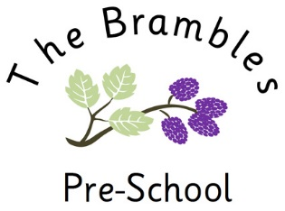 | The Brambles Preschool  Brampton Village Primary School  The Green, Brampton  Cambridgeshire  PE28 4RF  Tel 01480 375063 option 2  brambles@brampton.cambs.sch.uk  Leader: Emma Toseland
EXPRESSION OF INTEREST
Please complete and return this form to the preschool if you are interested in a place with us. Please note that this form adds you to our mailing list so that we can contact you when your child is eligible. It does not constitute an application for admission or a commitment by the preschool to offer your child a place. Admissions will be handled in accordance with our published policy.
Your Child’s Name
Your Child’s date of birth |  | Your child’s gender
Home language(s)
Your name
Your address
Your telephone number
Your email (please print)
Do you have children at the school? Please give name(s) and year group

By returning this form to us you are giving consent to the preschool holding these details until your child starts school. These forms will be held securely in accordance with GDPR, and you may contact at us at any time to ask for the form to be destroyed. Information about the preschool is published on the Brampton Village Primary School website, www.brampton.cambs.sch.uk. If you have questions about the setting, please telephone the number above between 9am and 3pm. Please be aware that we like to spend as much time as possible with the children, so you may need to leave a message on our answerphone.

